Supplemental table 1: Definition of postoperative atrial fibrillation in each study.

Trial | Definition of POAF
PARTNER I | New onset atrial fibrillation determined by an electrocardiography core laboratory
Corevalve | New onset or worsening of atrial fibrillation
SURTAVI | New onset or worsening of atrial fibrillation
PARTNER 2 | New onset atrial fibrillation
PARTNER 3 | New onset atrial fibrillation
NOTION | New onset or worsening atrial fibrillation during the immediate post-procedure course
Evolut | New onset atrial fibrillation

Supplemental table 2: Incidence of stroke, early mortality and readmission post AVR.

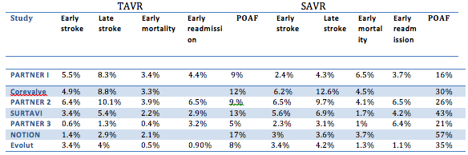
Supplemental table 3: Fixed and Random effect calculation of the odd ratio.

